Template to prepare Full Paper for ATI 2021 (Calibri, Bold 14pt centred)

First A. Author*¹, Second B. Author² and Third C. Author³ (Calibri, 12pt centred)
¹ Authors’ Department, Faculty, University, Country (Calibri, 10pt centred)
² Authors’ Department, Faculty, University, Country (Calibri, 10pt centred)
³ Authors’ Department, Faculty, University, Country (Calibri, 10pt centred)
*E-email (corresponding author)

Please indicate your preference for attending the symposium | ☐ online | ☐ in-person | ☐ not decided yet
Abstract (Calibri, bold 12pt left)
This document provides the instructions required to prepare the full paper to be submitted to the ATI2021. The abstract should briefly explain the motivation of your research and key aspects of the problem formulation, aim of the study and the methods utilized to achieve that aim. Key results should be summarized in a few sentences. The abstract should not exceed 250 words. The abstract should be formatted in Calibri 10 pt. justified, single space. Use a single paragraph.
Keywords (Calibri, bold 10p left): Between 3 and 5 words arranged in alphabetical order, separated by commas (Calibri, 10p).
Introduction (Calibri, bold 12pt left)
The papers must be written in English and should be laid out on A4 paper size. You can produce your paper by simply replacing the contents of this file. The length of the paper should not be longer than 12 pages. The minimum number of pages is 6. Please use the Calibri 10pt font supplied in this template. It is strongly recommended that your paper includes: a clear description of the problem addressed by the research; a contextualization of relevant previous work and how the present contribution is unique; a description of the methodology or approach used; and a discussion about the meaning, value, and impact of the results. Careful editing for clarity is also highly recommended. The text should be written in objective third person point of view throughout (Use "the authors" or "the researchers" NOT "I" or "we"). The paper must be divided into sections, where introduction and conclusion are compulsory.
Papers will be included in the symposium proceedings, which will be published as .pdf file. For this reason, the use of colour in figures and images is highly encouraged. However, please note that manuscripts will not be returned to the authors for revision, so please make sure that the submitted version contains neither orthographic nor grammar mistakes, as they will be published in the proceedings ‘as is’.
Headings (Calibri, bold 12pt left)
For the headings, please use the following formats:
- Heading 1: first level headline with Calibri, bold 12pt, left alignment
- Heading 2: second level headline with Calibri, bold 11pt, left alignment
- Heading 3: third level headline with Calibri, normal 10pt, left alignment
Do not use more than 3 sublevels.
Second-level subsection (Calibri, bold 11pt, left)
Third-level subsection (Calibri, normal 10pt, left)
Figures and Tables (Calibri, bold 12pt left)
Tables and figures should be sequentially numbered and referred in the text as ‘Table’ and ‘Figure’, respectively, (e.g. Figure 1). To create a table in MS Word, please use Insert>Table function. Do not paste it as image from another source. Figures should be embedded in the text and not uploaded as separate files. Make sure that all texts in the figure are legible.

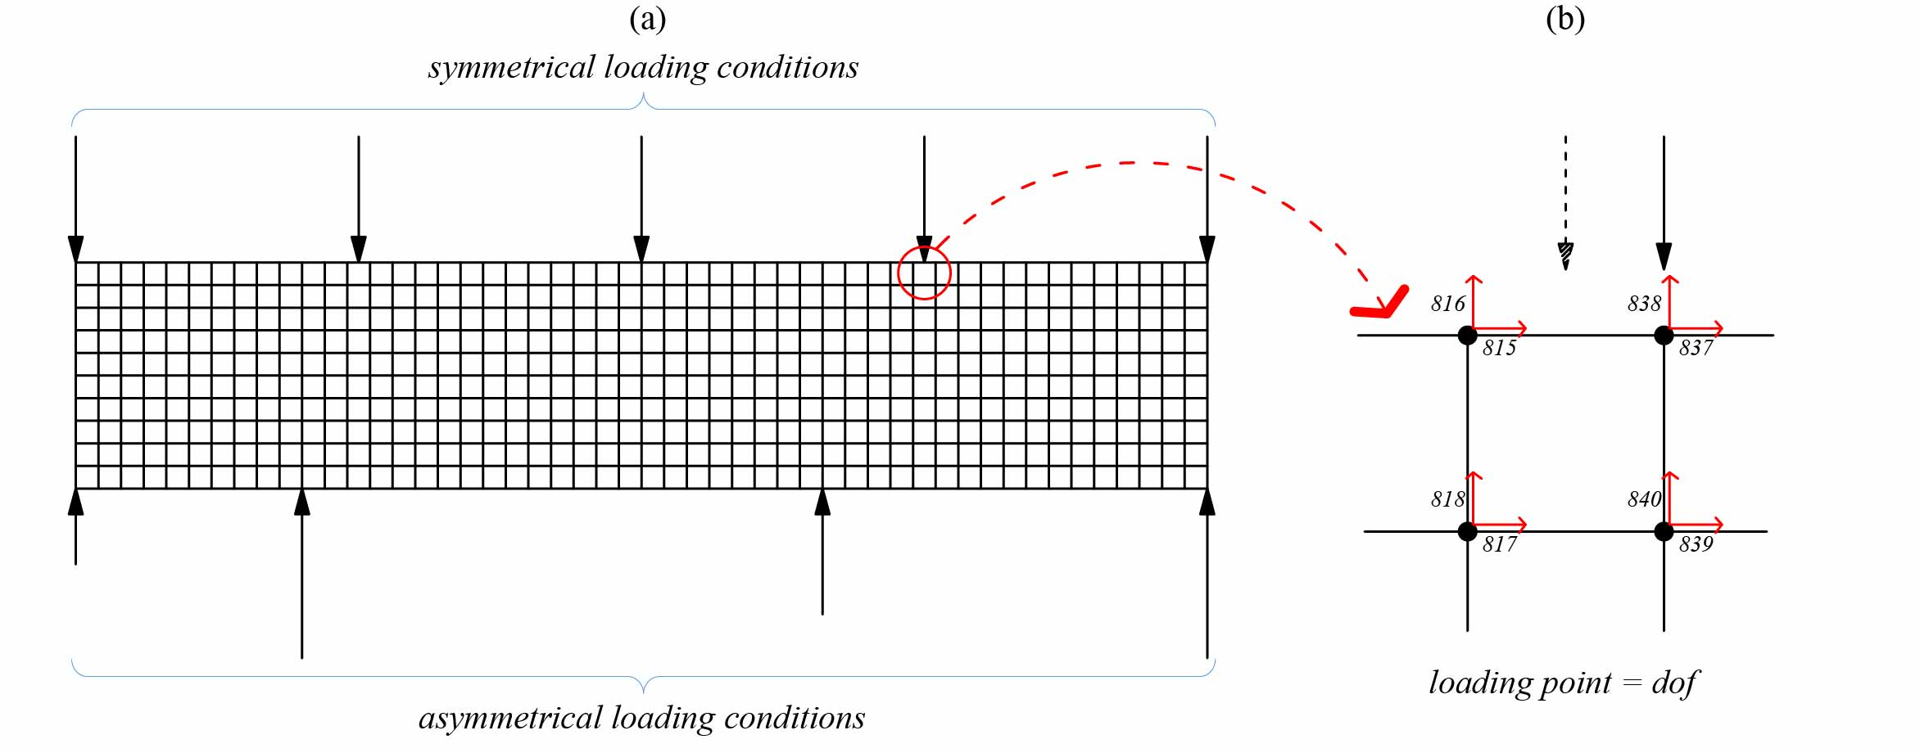
Figure 1. Figure captions should use Calibri 9pt (with source credits if necessary).

Table 1: Table captions should use Calibri 9pt (Source: Calibri 9pt., italics)
Calibri 9pt | Calibri 9pt | Calibri 9pt
Calibri 9pt | Calibri 9pt | Calibri 9pt
Calibri 9pt | Calibri 9pt | Calibri 9pt
Calibri 9pt | Calibri 9pt | Calibri 9pt
Equations (Calibri, bold 12pt left)
Please use Microsoft Equation Editor to insert the equations in your paper (Insert | Object | Create New | Microsoft Equation or MathType Equation). Do not use Print Screen or jpg format. Equations should be cross-referred in the text using Eq. 1, Eq. 2, and so on. Number equations consecutively with equation numbers in parentheses, as in the following example:
(1)
Selected Papers (Calibri, bold 12pt left)
Selected papers will be published in a special issue of the International Journal of Digital Innovation in the Built Environment (https://www.igi-global.com/journal/international-journal-digital-innovation-built/224363). The selection will be made according to both the score of the extended abstract and the evaluation of the full paper.
Conclusion: Upload your work (Calibri, bold 12pt left)
You must upload your work as a MS Word (.docx), using your Easychair account link https://easychair.org/conferences/?conf=ati2. Instructions for uploading your paper will be sent to your e-mail in the coming weeks.
Acknowledgements (Calibri, bold 12pt left)
This section is for the authors to acknowledge assistance or support from colleagues, technical staff and/or financial support from universities and organizations.
References (Calibri, bold 12pt left)
References follow APA styles (American Psychological Association 6th edition – more information http://www.apastyle.org/). In-text references should use (authors, year) format. For example (Cichocki & Unbehaven, 1993).

Books:
Cichocki, A. and Unbehaven, R., (1993). Neural Networks for Optimization and Signal Processing, 1st ed. Chichester, U.K.: Wiley.

Journal Articles:
Guo, Y., & Li, Y. (2016). Getting ready for mega disasters: the role of past experience in changing disaster consciousness. Disaster Prevention and Management: An International Journal, 25(4), 492–505.

Online Sources style
Vidmar, R. J. (August 1992). On the use of atmospheric plasmas as electromagnetic reflectors. IEEE Trans. Plasma Sci. [Online]. 21(3). pp. 876-880. Available: http://www.halcyon.com/pub/journals/21ps03-vidmar

Conference Proceedings Format
Beck, K. and Ralph, J. (1994). Patterns Generates Architectures. Proceedings of European Conference of Object-Oriented Programming. Bologna, Italy, pp. 139-149.

