Title of Your Abstract (Calibri, Bold 14pt centred)

First A. Author*¹, Second B. Author² and Third C. Author³ (Calibri, 12pt centred)
¹ Authors’ Department, Faculty, University, Country (Calibri, 10pt centred)
² Authors’ Department, Faculty, University, Country (Calibri, 10pt centred)
³ Authors’ Department, Faculty, University, Country (Calibri, 10pt centred)
*E-email (corresponding author)

Please indicate your preference for attending the symposium | ☐ online | ☐ in-person | ☐ not decided yet

Abstract (Calibri, bold 12pt left)
This document provides the instructions required to prepare the abstract to be submitted to ATI 2022. The abstract should be written in English and in MS Word format (Calibri 11 pt. justified, single space). However, it must be submitted as a PDF, using the link you find in the ATI website. Do not indent the text paragraphs. The abstract first states the paper’s title, author(s) name (s), authors’ affiliation, followed by the Abstract's text and the keywords (up to five words). The corresponding author should be indicated with an asterisk (*).

Authors are requested to submit abstracts (300 – 500 words, excluding references) in electronic form. The abstract should briefly address the background and scope of your research including the problem formulation, the aim and objective, materials and methods, results and discussion, and the main conclusions of the study. A relevant figure can be included in the abstract, provided that it is referred to in the text (e.g. Figure 1). Relevant references should be cited using numbers in brackets, i.e. [1], [2].

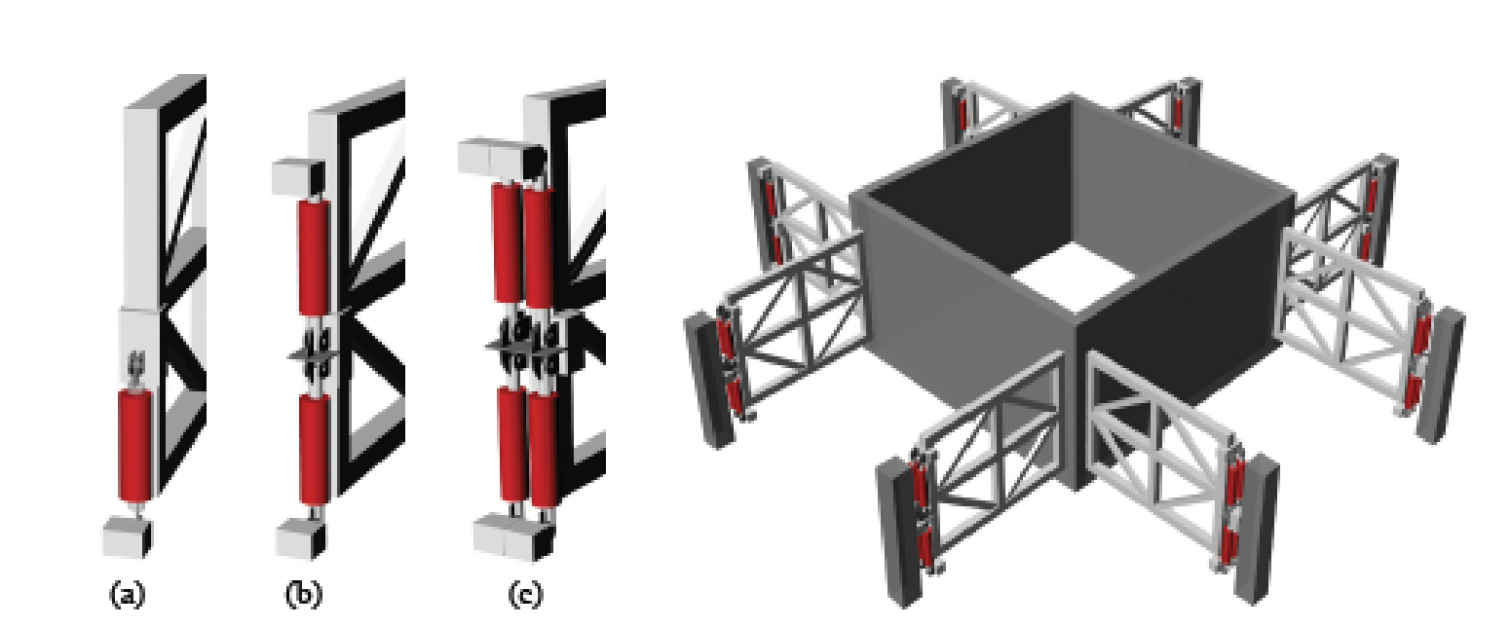
Figure 1. Example image to be used in the extended abstract.

Keywords (Calibri, bold 11p left): Between 3 and 5 words arranged in alphabetical order (Calibri, bold 11p).

References (Calibri, bold 12pt left)
[1] Spiller, N. (2010), Digital Solipsisim and the Paradox of the Great ‘Forgetting’. Archit Design, 80: 130-134. https://doi.org/10.1002/ad.1117
[2] Soares, H. M., Tomotani, J. V., Tomotani, B. M., & Salvador, R. B. (2019). Bird biodiversity in heavy metal songs. Journal of Geek Studies 6(2): 111-126.
[3] Beeston, D. (2009). The early years of Albert Einstein: When viewed through the lens of current theory and research were there signs of giftedness? APEX, 15(4), 56-77.

